**CURRICULUM VITAE**

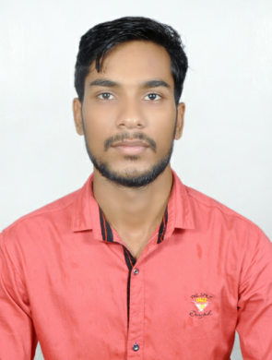

**SAGAR SAHOO**

D.O.B.**:** 09-Jun-1994

Nationality**:** India

Location**:** Rourkela , Orissa , India

Mobile**:** +91 7008158868 **,** 7873453464

Email: sagarsahoo68447@gmail**.**com

Indian Passport no: N9901969

# CAREER OBJECTIVE

To have a growth oriented and challenging career, where I can contribute my knowledge and skills to the organization and enhance my experience through continuous learning and teamwork.

# EDUCATION

* Govt**.** Polytechnic Bolangir **,** Orissa**,** India**.**

Diploma in Mechanical Engg**.** Completed 2017**.**

* Vedvyas mahavidyalaya Rourkela **,** Orissa **,**India**.**

+2 science completed at 2012**.**

* Hari Har High School Kuarmunda **,** Orissa**,** India**.**

Matriculated completed 2010**.**

**PROFESSIONAL EXPERIENCE**

* Sales and Service in Ashok Leyland Shree Jagannath Motors Rourkela (May 2013 -Aug 2015)**.**
* Field Service Engineer in Ashok Leyland Shree Jagannath Motors Rourkela (Aug 2017 to continue)**.**

**RESPONSIBILITIES AND ROLE DETAILS**

* Assessing customer feedback**.**
* **Tight control over FOC Warranty jobs.**
* **Visit the customers for attending to technical jobs viz., assessments, fault finding, repairs, periodic servicing, refurbishing etc.**
* Judicious Warranty disbursement for reducing Warranty Expenses
* Handling complaints relating to service**,** warranty and quality standards**.**
* Collecting & collating data on repeat jobs**/** other specific complaints & discuss the same with the manufacturing team for counter measures**.**
* Interacting with customers for solving their technical problems**.**
* Maintain safety during works**.**
* Training and motivating workers**.**
* Generating detailed daily**,** monthly**,** quarterly and yearly reports on business and profit**.**
* Maintaining a proper inventory of spare for smooth execution of service operations**.**
* minimize repeat repair to achieve customer satisfaction & service revenue target by receiving customer consistent vehicles**.**

# SPECIALIZED SKILLS

* Excellent interpersonal and communication skills**.**
* Ability to diagnose vehicle issues and present accurate estimates**.**
* Expert knowledge of handling administration and paperwork**.**
* Thorough insights in overseeing stock levels and ordering supplies**.**
* Impressive ability to motivate staff **.**
* Expert marketing skills to promote business**.**

**SOFTWARE PROFICIENCY**

* AutoCAD from CTTC Bhubaneswar**.**
* MS-Office

# LANGUAGES

* English – Excellent reading, writing and speaking**.**
* Hindi – Excellent reading, writing and speaking**.**
* Oriya – Excellent reading, Writing and speaking**.**

# OTHER INTERESTS

Playing cricket**,** Bike Riding**,** watching YouTube videos**,** Gadgets freak**.**

**PROSONAL PROFILE**

Gender  **:** male

Marital status  **:** Single

Permanent Address **:** Kuarmunda bhattitoli**,** Rourkela**,** Odisha (770039)**.**

**DECLARATION**

**I hear by declare that the above mentioned information is correcr up to my knowledge and I hear the responsibility for the correctness of the above mentioned particulars.**

**Place:**

**Date: Signature**